MHHS Design Change Management Procedure

Document owner | Document number | Version
Paul Pettitt | MHHS-DEL744 | 0.8
Status: | Date | Classification
DAG Approval | 15 December 2022 | Public

Document owner | Document number | Date

Contents
1 Contents 1
1.1 Change Record 2
1.2 Reviewers 2
1.3 Approver 2
1.4 References 2
1.5 Glossary 2
2 Purpose 4
3 Objectives 4
4 Scope 4
5 Change Management Process flow 5
5.1 Design and Programme Change Process Relationship 5
5.2 Raise Request for Change 7
5.3 Capture Log and Check RFC 7
5.4 Categorisation of RFC 8
5.5 Review RFCs 8
5.6 Expedited Change 9
5.7 Assess Change Impacts 10
5.8 Scheduling Design Change Work 12
5.9 Implement Design Changes 12
5.10 Monitor RFC Status 12
5.11 RFC Closure and Post Implementation Review 13
6 RACI for Change Management 13
7 Example Change Management Log 14
8 Request for Change Form 15
8.1 RFC Guidance Notes 17

Change Record
Date | Author | Version | Change Detail
28 October 2022 | Paul Pettitt | 0.1 | Initial Draft
03 November 2022 | Rob Topley | 0.2 | Revised
04 November 2022 | Paul Pettitt | 0.3 | Update following internal review
07 November 2022 | Paul Pettitt | 0.4 | Issued for SRO Review
25 November 2022 | Paul Pettitt | 0.5 | Updated following SRO review
2 December 2022 | Paul Pettitt | 0.6 | Further update following SRO review
7 December 2022 | Paul Pettitt | 0.7 | For DAG Approval
15 December 2022 | Paul Pettitt | 0.8 | For approval following updates following DAG comments

Reviewers
Reviewer | Role
Ian Smith | MHHS Design Lead
Adrian Ackroyd | MHHS Test Lead
Warren Fulton | MHHS Delivery
Marc Towers | MHHS LDP Quality Assurance
Claire Silk | MHHS Engagement Lead
Smitha Pichrikat | MHHS Client Delivery Programme Manager
Simon Harrison | MHHS LDP Design Lead
Rob Topley | MHHS LDP Business Architect
Ross Catley | MHHS LDP Architect
Colin Bezant | Independent Programme Assurance

Approver
Approver | Role
Ian Smith | SRO MHHS Design Lead
Design Advisory Group

References
Document No | Title | Version | Date
MHHS-DEL714 | SI Design Management Approach | 1.0 | 26 Oct 2022
MHHS-DEL171 | Change Control Approach | 1.0 | 05-May-2022
MHHSP-DES189 | Design Artefact Matrix | 1.1 | 01-Nov-2022
MHHS-DEL763 | Design Release Management Approach | 0.4
MHHS-DEL764 | Design Configuration Management Plan | 0.3

Glossary
Term | Description
Change | The addition, modification, or removal of anything that could influence the MHHS Programme design.
Design Advisory Group (DAG) | The Design Advisory Group is responsible for assessing the impact of requested changes and estimating the impact on the design and TOM. They will advise the Change Manager on whether changes should be approved and will assist in scheduling changes. The DAG’s ToR are here link.
Design Authority (DA) | The DA role is to manage the MHHS Design Baseline by reviewing potential changes and developing prospective changes to the baselined Design Artefacts raised by Programme Participants following commencement of M5 baseline approval. The DA will provide system design advice on potential changes and will ensure Programme Participants are represented and relevant experts engaged in the assessment of design issues and in the development of prospective solutions.
Change Record | A record containing the details of a change. Each change record documents the lifecycle of a single change. A change record is created for every request for change that is received, even those that are subsequently rejected. Change records should reference the configuration items that are affected by the change. Change records may be stored in the configuration management system, or elsewhere in the service knowledge management system.
Change Schedule | A Document that lists all approved Change Proposals and Changes and their planned implementation dates.
Change Window | A regular, agreed time when changes or releases may be implemented with minimal impact on services.
Expedited Change | A Change that must be introduced as soon as possible – for example, to resolve a major incident that prevents MHHS processes operating.
Post-Implementation Review (PIR) | Post Implementation Review is the assessment of deployed changes after deployment and after a predefined period. It determines if the change or project was successful and identifies opportunities for improvement.
Minor Change | A change that needs only a clarification back to the change party on how the design operates or fixes an administrative error such as a typo. These changes must be agreed unanimously, or they will be treated as a major change.
Major Change | Any change which is not a minor change, which will be referred to the DAG for decision

Purpose
This document builds on the high-level SI Design Management approach as detailed in MHHS-DEL714 in defining the process of assessment, analysis, and implementation of change to the baselined MHHS Design artefacts.
This process supports the Programme Change Control Approach MHHS-DEL171 in addressing changes to baselined programme design artefacts.
The processes follow Information Technology Infrastructure Library (ITIL) methodologies and describes processes, procedures, tasks, and checklists used for managing the authorised and planned activities relating to any baselined items of a MHHS Artefacts.

Objectives
The objective of Change Management is to:
      - Respond to the Participants changing business requirements while maximizing value and reducing incidents, disruption, and re-work.
      - Respond to the business and requests for change that will align the services with the business needs
      - Ensure that changes are recorded and evaluated, and that authorised changes are prioritised, planned, tested, implemented, documented, and reviewed in a controlled manner
      - Ensure that failed changes are analysed to reduce the reoccurrence of such instances. Check points are enforced to understand the progress of change and to understand the failures.
      - Ensure that all changes to configuration items are recorded in design repository.
      - Minimise overall business risk.

Scope
Scope of Design Change Management Process can be defined as changes that affect those artefacts as defined in the Programme Artefact Matrix (MHHSP-DES189-Design Artefact Matrix) including:
      - MHHS Programme developed Artefacts
      - Business Processes Diagrams
      - Documentation, e.g., Method statements, process descriptions
      - Configuration Items e.g., the Industry Standing Data
      - Supporting design documentation

Excluded from scope is:
      - Changes to Industry Artefacts outside of the MHHS Programme, e.g., SAA Service description, BSCPs,
      - Consequential Changes that fall outside of the MHHS Programme governance
      - Commercial / Service Provider contract amendment

Change Management Process flow
Change is expected to originate from several sources, see Figure 1 below. The Design Change Triage Group (DCTG) Section - 5.3 will act as a front door for all change, performing triage to ascertain the next best step. The DCTG will maintain several tools to provide the programme and participants with full transparency on all change matters.

The MHHS Design Authority (DA) will be the engine room of design change decisions, taking account of all impacted parties and recording options and potential technical debt. The DA will, if required, establish working groups (Design Issue Resolution Groups) to support the production of recommendations on proposed change to the programme.

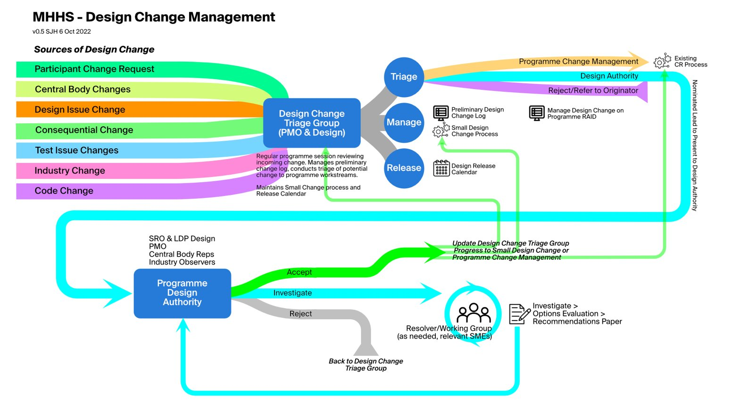
Figure 1 - Design Change Overview

Design and Programme Change Process Relationship
There are two scenarios where a design Impact Assessment (IA) will work within programme governance. The first is if a design change request identifies impacts to time and cost. In this case the DA will recommend to DAG to raise a Programme Change Request to follow the programme CR process. The IA will be part of the submission of the CR, so effort is not duplicated, and the Programme Change Board and PSG will either approve or reject the request.
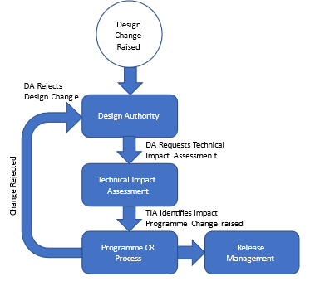
The second scenario is if a Programme Change Request is raised that involves a design change. In this case the DA will review the CR Impact Assessment and look at solution options before presenting to DAG their findings. This Impact Assessment will be returned to the Programme CR process.
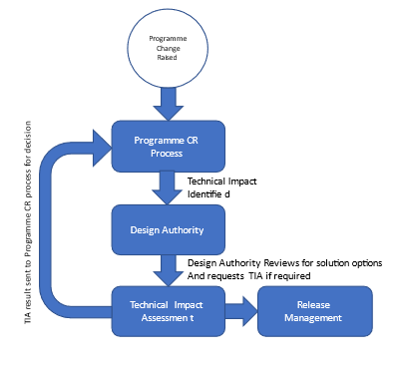

The following process flow diagram and subsequent sections explains in detail the responsibilities and tasks for the design change process:

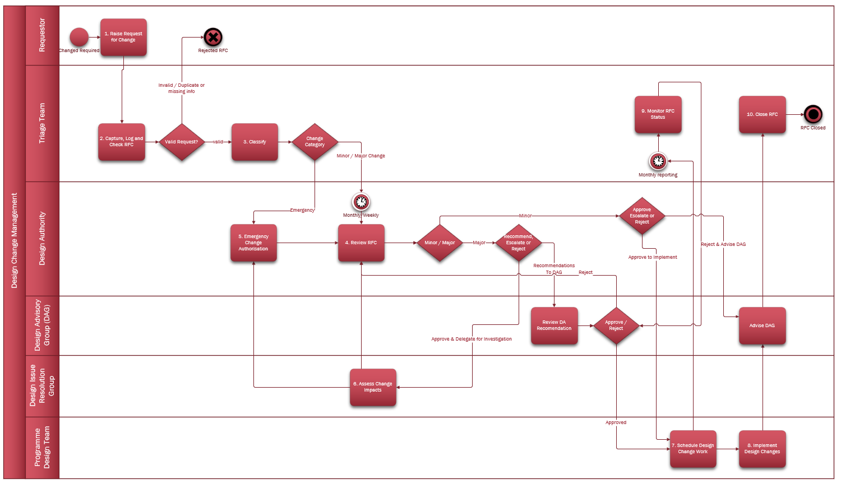 Figure 2 - SI Design Change Process Model

Raise Request for Change
This process starts with a potential change that will become a Request for Change (RFC), these requests can come from multiple sources both internal and external as illustrated in Figure 1.
The proposer (or person raising on behalf of the proposer) must complete the Request for Change form (see Section 8) and send to SI Design team.

Capture Log and Check RFC
When an RFC form is completed and submitted the RFC is recorded within the Change Log and given a unique Change Reference, created date/time stamp and an initial status of “New”. All RFC’s will be logged tracked, monitored, and updated throughout their life cycle (see Section 7 for Example Change log).
Participants will be kept informed of changes via the channels of the Collaboration Base and weekly Clock publication.
The objective of this step is to filter out Requests for Change which do not contain all information required for assessment or are duplicate.
The DCTG will identify all new RFCs and perform the following checks:
- Check RFC is not a duplicate or similar to an existing RFC already raised.
- Check RFC form for completeness.

If the RFC is not complete or a duplicate, then
- Capture reviewed by name and date
- Liaise with the Proposer to update prior to rejection
- Change the status to rejected and reason for rejection
- Inform the proposer of RFC of any rework needed prior to resubmission or rejection
- If the RFC is a duplicate of an existing RFC, then
  - update the RFC to reference the original RFC

Categorisation of RFC
The objective of this step is to initially assess RFCs and classify the required level of authorisation for the assessment of a proposed Change.
If the new RFC is valid then the DCTG will.
Perform an initial assessment: The DCTG will consider the 7R’s of the Change Management.
- Who Raised the change?
- What is the Reason for the change?
- What is the Return / outcome required from the change?
- What are the Risks involved in the change in either to proceed or not to proceed?
- What Resources are required to assess deliver the change?
- Who is Responsible for the assessment, test, and implementation of the change?
- What is the Relationship between this change and other changes?
The DCTG can contact the requestor for clarification or more information.
Based on the assessment the change is updated:
- Classify RFC as either Expedited, Major or Minor change (see appendix for change classification table).
- Add any addition information about the change assessment
- Reviewed by and review date is completed
- Status is updated to Open
In some cases where the change is deemed not required e.g., where the change is duplicated or previously rejected then the change is updated:
- Add explanatory rationale information about the change assessment outcome
- Reviewed by and review date is completed
- Status is updated to Closed

Major changes are reviewed by the Design Authority and authorised by the Design Advisory Group, Minor changes are reviewed and authorised see section 5.5.
Expedited Changes see Section 5.6.

Review RFCs
The MHHS Design Authority (DA) will meet on a regular basis (nominally monthly) to assess all proposed (Open) Major and Minor RFCs and determine the actions to take. Or the DA sets up the required Design Issue Resolution Group(s) if the DA determines the RFC warrants more in-depth analysis/work to process the RFC.
The DA will also review and assess any RFCs which have been assigned to a Design Issue Resolution Groups and are now ready for review.
For each RFC, the DA will:
- understand the effects of the RFC and identify predicted impacts / performance impacts on PPs. This can be determined from the requirements mentioned in the RFC, acceptance criteria, discussing with relevant PPs.
- assess risks and conducts analysis with respect to impact on the design or TOM of the change to find if the proposed change is a viable option.
The analysis will include different factors:
- Cost-benefit (Cost effectiveness)
- Resource availability
- Identified Risks
- Impact on the design, the TOM and associated artefacts
- Regulatory or Code requirements (if any)
For Minor changes sufficient information should already be present within the RFC to review, this will be discussed and subject to unanimous agreement by DA taken forward to for the design to be updated and communicated to DAG and industry.
For some Major changes, this may involve the bringing together of SMEs in a Design Issue Resolution Groups to recommend the best approach, impacts on other changes and implementation dates (see section 5.6 Assess Change Impacts).
Based on the DA review Outcome:
If RFC is accepted, then
- Update RFC status to Accepted
- Log DA Review date
If RFC requires further investigation, then
- Update the RFC status to Investigation
- Identify the Design Workgroup assigned (or SME)
- Log DA review date
If RFC is rejected, then
- Update the RFC status to Rejected
- Record the reason for rejection
- Log Da Review date
If an RFC (or set of RFCs) has Major impact on Programme timescales or costs, then
- Recommend to DAG a CR is raised with the programme to escalate the RFC(s) before these changes can be actioned
- Update the RFC status to Escalated
- Record the CR raised against the RFC(s)
- Log DA review date
Whether via direct DA analysis or a Design Issue Resolution Group present the outcomes along with recommendations / escalations to the Design Advisory Group for review approval and subsequent implementation.
Inform the original requestor of review outcome for the RFC.

Expedited Change
Where the DCTG has identified that an RFC has a major and immediate impact on the MHHS service an extraordinary Design Authority meeting will be convened in which the Expedited RFC will be reviewed.
Within three working days the DCTG will request the Design Authority review any Expedited changes. It is not intended to address Expedited changes outside of normal working hours.
This step assesses and recommends to DAG the impact on the design and a course of mitigating action where appropriate . This process is invoked if normal Change Management procedures cannot be applied because an Expedited requires immediate action.
The Design Authority will review recommend to DAG if an Expedited change is required.
If an Expedited is not deemed necessary, then
- Reclassify the RFC to Major / Minor change
- Add comments to reflect non-Expedited reason
If an Expedited change is recommended, then
- Change RFC Status to Accepted
- Update the DA review date
Notification of the Expedited change recommendation will be sent to the following:
- Change Initiator
- SI Design Lead
- SRO Design Lead
- Configuration Manager
- Domain Subject Matter Expert(s)
- Design Advisory Group.

Assess Change Impacts
Major Changes are passed on from the Design Authority for assessment, this may involve the bringing together of SMEs via a Design Issue Resolution Groups to agree the best approach, impacts on other changes and implementation dates. The Design Authority will provide clear guidelines to the working group on assessments and expected response times.

Design Issue Resolution Groups will meet as agreed by the DA in order provide a detailed analysis of solution options and impacts. The analysis could include different factors like:
- Cost-benefit (Cost effectiveness)
- Resource availability
- Identified Risks
- Impact on other services and business impact
- Compliance requirements (if any)
- Impact on regulatory code
- Impacts on test requirements and subsequent testing
The Design Issue Resolution Group will report back findings and recommendations at the next Design Authority meeting.
Additional details of solutions will be attached to the RFC by the Design Issue Resolution Group.

Scheduling Design Change Work
The purpose of this step is to plan, schedule and control the delivery of all approved RFC’s.
The SI Design team will:
- Review the current list of planned RFCs and any newly approved RFC’s
- Follow the Release Management as defined in the release management procedures to prepare the Forward Schedule for Design Change after considering all currently planned RFCs which are still open for implementation. Also, the ongoing RFC implementations are considered when preparing the schedule of changes. Design changes of similar kind are grouped together to help release planning.
- Assess the work plan for conflicts with other planned/ongoing changes and to check resource availability
- Identify the resources to be assigned to makes changes to the design configuration items
- Update the RFC change log with the details of the Release the RFC is planned for
- Change RFC status from approved to Planned
- Depending on the nature of the RFC, a recommendation is made to DAG on the requirement of a formal industry consultation.
- Based on the criteria for evaluation after planning and before implementation, the project plan as well as the test plan are reviewed and evaluated.

Implement Design Changes
The purpose of this stage is to deliver all required change(s) for an RFC to the configuration items/components in the design and where necessary properly assure, and to authorize the change deployment. This only relates to implementation of the design artefacts and not implementation of the solution.
The SI Design team will:
- Update the design configuration item as identified by the RFC following the Configuration Management Plan procedures
- Produce an assurance Plan, to ensure all design artefacts within the configuration management system which are changed or impacted by a change are properly updated to meet requirements and verified.
- Assuming successful assurance completion deploy the design changes and provide the related/relevant release documents for the changes following the Release Management procedures.

Monitor RFC Status
The purpose of this step is to regularly review the status, manage and control the delivery of RFCs. It provides the oversight required to ensure that changes are properly managed and authorised. The status of RFCs will be made available on the collaboration base and using the weekly Clock publication.

The DCTG will on a monthly basis:
- Provide a report on the number of RFCs and breakdown by status
- Track any RFC’s awaiting escalation or implementation
- Track any RFCs with Working Group or SMEs for detailed impact analysis
- Handle any disputes with RFC’s. If a proposer of a change request is not satisfied with a change decision, then refer it to DAG.
- Analyse and identify lessons learnt from the whole lifecycle of the change. Collate all post implementation analysis and assessment information in the Change Evaluation report

RFC Closure and Post Implementation Review
Post Implementation Review (PIR) assesses the design change implementation and the achieved results, to verify that a complete history of activities are present for future reference, and to make sure that any challenges are analysed, and lessons learned.
The DCTG will for each RFC delivered:
- Determine if a formal evaluation is required post the deployment.
- Determine if the implementation of the change achieved its objectives.
- Find how the implementation of change can be improved and update the Continual Service Improvement register for initiating an updated Service Improvement Plan.
- Determine if such change is likely to recur in future. If so, then a new change model might be necessary to handle such changes in future.
- Update the change record with relevant inputs and set the status to “Closed” to formally close the RFC.
Any outputs from a formal PIR will be presented back to the DA and DAG with recommendations and timescales for remedial actions and owners where required.

RACI for Change Management
Activity |  | DCTG |  | Change Proposer | SI Design Team | Working Group/ SME | DAG | Design Authority | Market Participant
Raise request for change |  |  |  | AR
Capture Log and Check RFC |  | AR |  | C |  |  |  | I | I
Categorisation of RFC |  | R |  | I |  |  | I | A | I
Review RFCs |  | C |  | I |  |  | A | R | C
Expedited Change Authorisation |  | R |  | I |  |  | A | R | I
Assess Change Impacts |  | I |  | C |  | R | I | A
Scheduling Design Change Work |  | R |  | I | A |  | I | C | C
Implement Design Artefact Changes |  | I |  | I | A |  | I | R | I
Monitor RFC Status |  | R |  |  | I |  | I | A | I
RFC Closure |  | R |  | I |  |  | A | C | I
Responsible (R) - Those who do work to achieve the activity.
Accountable (A) - The resource ultimately accountable for the completion of the task.
Consulted (C) - Those whose opinions are sought. Two-way communication.
Informed (I) - Need to be informed about the activity.

Example Change Management Log
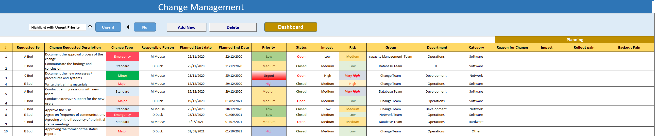

Request for Change Form
Change Request No.:

Major RFC
Change Proposer Details
Date submitted: |  |  | Company:
Date required: |  |  | Department:
Proposer name: |  |  | Manager's name:
Email: |  |  | Manager's email:
Phone: |  |  | Manager's phone:
Basic details
Short Description:
Detailed description:
Justification:
Location:
Attachments:
Change Management Analysis
Category: |  |  | Change Manager:
Type: |  |  | Change Builder:
Item: |  |  | Change Tester:
Impact: |  |  | Assignment group:
Urgency: |  |  | DAG members needed:
Priority: |  |  | CIs involved:
Initial Risk Rating: |  |  | Impacted Services:
Short term benefits:
Long term benefits:
Pros and Cons:
Evaluation
Who RAISED the change?
What is the REASON for the change?

What is the RETURN required from the change?
What are the RISKS involved in the change?
What RESOURCES are required to deliver the change?
Who is RESPONSIBLE for the build, test, and implementation of the change?
What is the RELATIONSHIP between this change and other changes?
Risk analysis
Type of risk: [social, financial, organizational, external]
Risk Impact: [trivial, minor, moderate, major, and catastrophic]
Likelihood: [1,2,3,4]
Probability: [1,2,3,4]
Risk Consequences:
Planning details
Implementation plan
Remediation plan
Backout plan
Test plan
Financial details
Relative cost:
Estimated effort in man days:
SLAs associated:
Approximate cost:
Associated tickets
Associated Incidents
Associated Problems
Associated Change
Scheduling Details
Planned start date: |  |  | Actual start date:
Planned end date: |  |  | Actual end date:
DAG required: |  |  | DAG Recommendations:
DAG date:
PIR
Change Closure Information
Closure code:
Closure notes:

RFC Guidance Notes

RFC Number: a unique ID registered for the change
Change Description: the description of the change
Change Location: the location where the change will be implemented
Change Proposer: the person who requested the change request/RFC
Change Analyst: the name of the change analyst who will analyse the change request/RFC
Change Requested Date: the date on which the change was requested
Change Triggered By: defines the sources that triggered the change like legal requirements, business requirements, etc.
Change Classification: the classification of the change like Minor, Major, and Expedited
Category: the category of the change
Type: the type of change
Item: item of the change
Assignment group: The group assigned to own and implement the Change Request
Risk analysis: describes the risks associated with the change
Business Case: the plan which defines the business justification, benefits, and resources needed
Rollback Plan: the description of the rollback plan
Risk analysis: the description of the risk analysis
Remediation Plan: the description of the remediation plan
Impacting Services: the services that will be impacted by the change
Impacting CIs: the CIs that will be impacted by the change
Relative Benefit of Implementing the Change: the benefit of implementing change
Relative Cost: This should define the relative costs
Estimated Effort in Man Days or Hours: Man, days, or hours
Change Approval/Rejected Date: the date and time when the change was approved/ rejected by DAG
DAG Decision: a decision made by the DAG
DAG Comments: comments given by the DAG
Change Manager: name of the change manager
Impact: The number of people that will be affected by change
Urgency: how soon the change must be implemented
Priority: It will be based on impact and urgency
SLAs Associated: SLAs associated with change management
SLA Target Date and Time: date and time when the SLAs will be breached with respect to the change
Major Change Review: This determines if it's a major change
Major Change Justification: This defines the business justification and why it should be treated as a major change
Associated Incidents: the details of the incident tickets that are associated with this change
Associated Problems: the details of the problem tickets that are associated with this change
SLAs Breach Details: the description why the SLAs were breached, and by how many minutes or hours did we breach the SLAs.
PIR: defines the lessons learnt

A likely example of emergency change to be as an outcome of testing.

